**A. KPI’s**

1. **Total Revenue:**

Select SUM(total_price) AS Total_Revenue from pizza_sales;

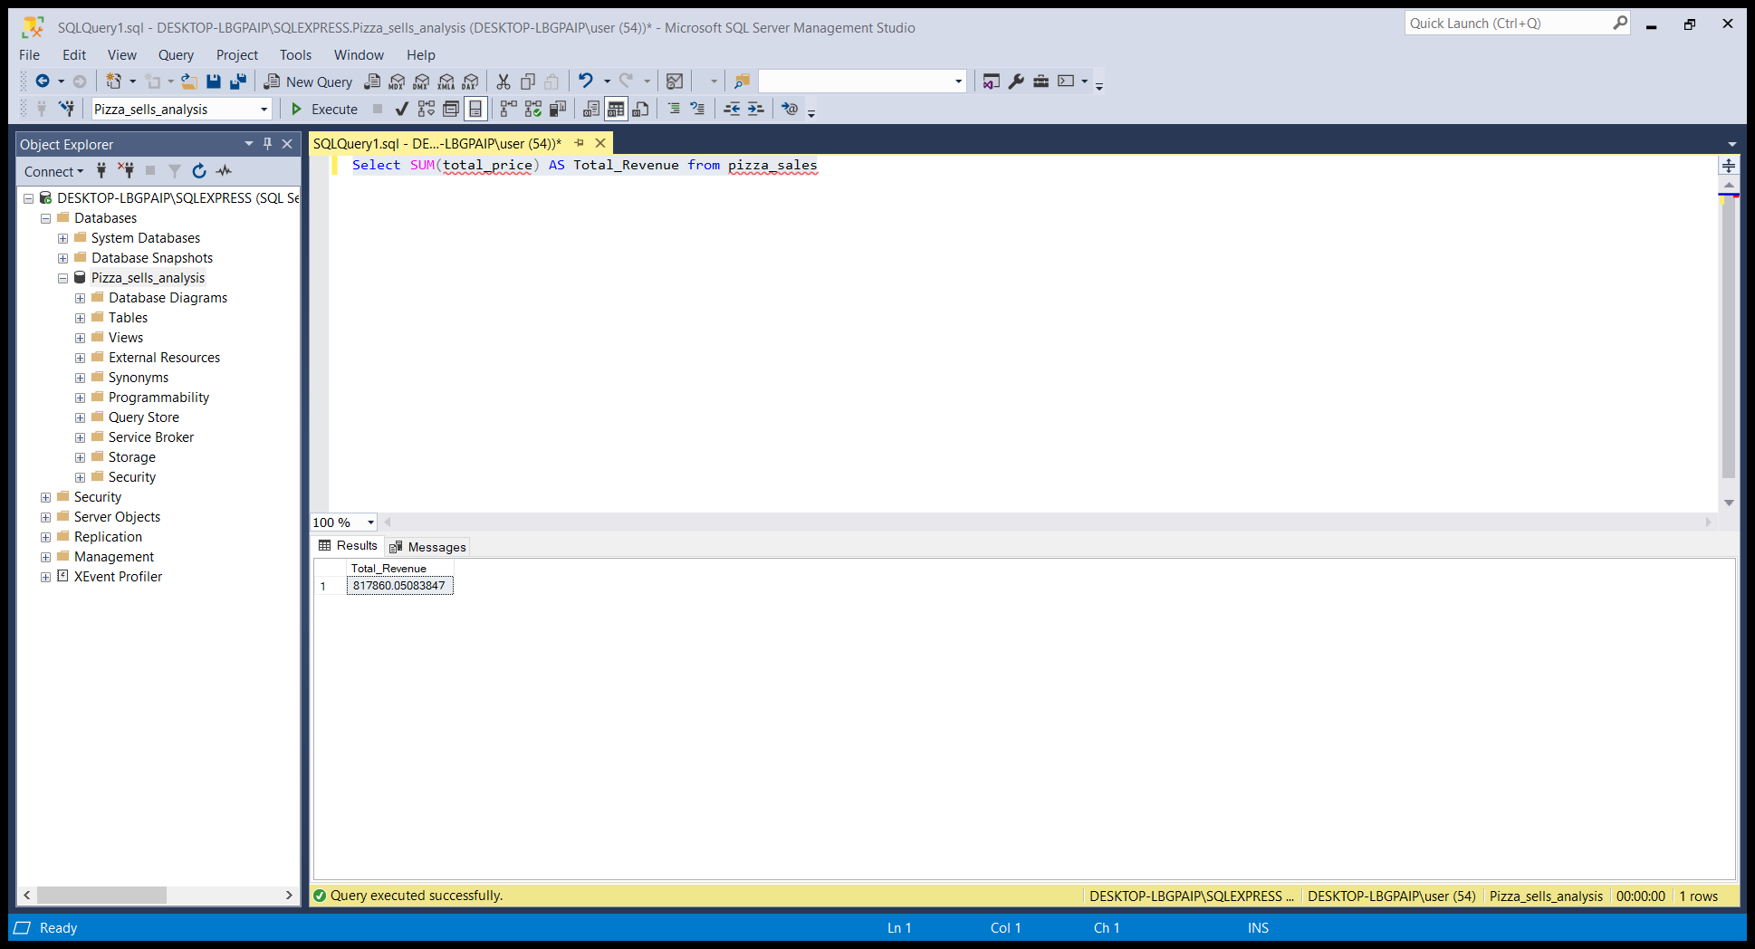

1. **Average Order Value:**

Select SUM(total_price)/ COUNT(DISTINCT order_id) AS Avg_Order_Value from pizza_sales

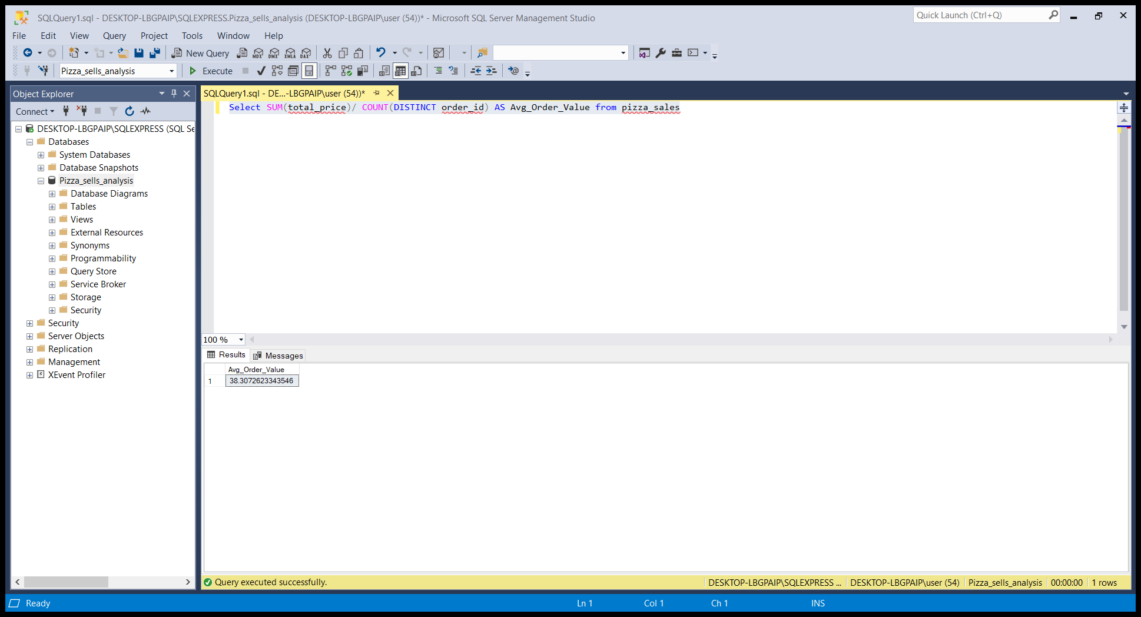

1. **Total Pizza Sold:**

Select SUM(quantity) AS Total_Pizza_Sold from pizza_sales

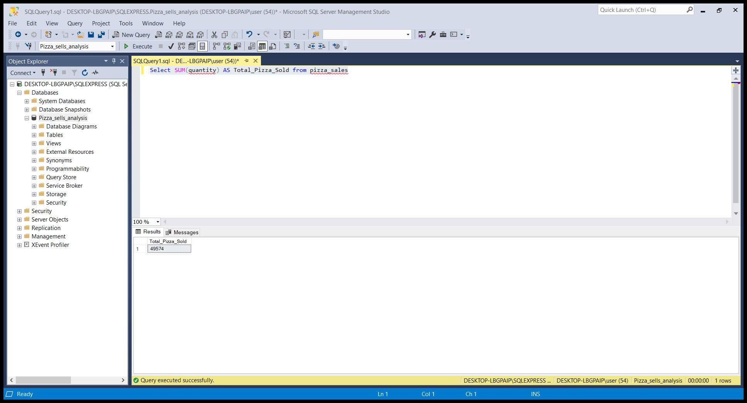

1. **Total Orders:**

Select COUNT(DISTINCT order_id) AS Total_Orders from pizza_sales;

1. **Average Pizza Per Orders:**

Select CAST(CAST(SUM(quantity) AS decimal(10,2))/CAST(COUNT(DISTINCT order_id) AS decimal(10,2))AS decimal(10,2)) AS Avg_Pizzas_Per_Order from pizza_sales;

**B. Daily Trend for Total Orders**

SELECT DATENAME(DW, order_date) AS order_day,

COUNT(DISTINCT order_id) AS total_orders

FROM pizza_sales

GROUP BY DATENAME(DW, order_date)

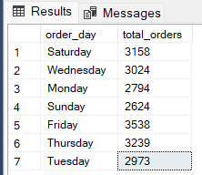

**C. Monthly Trend for Orders**

SELECT DATENAME(MONTH, order_date) as Month_Name,

COUNT(DISTINCT order_id) as Total_Orders

FROM pizza_sales

GROUP BY DATENAME(MONTH, order_date)

**D. % of Sales by Pizza Category**

SELECT pizza_category, CAST(SUM(total_price)

AS DECIMAL(10,2)) as total_revenue,CAST(SUM(total_price) * 100 /

(SELECT SUM(total_price) from pizza_sales)

AS DECIMAL(10,2)) AS PCT FROM pizza_sales

GROUP BY pizza_category

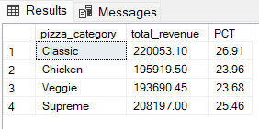

**E. % of Sales by Pizza Size**

SELECT pizza_size, CAST(SUM(total_price)

AS DECIMAL(10,2)) as total_revenue, CAST(SUM(total_price) * 100 /

(SELECT SUM(total_price) from pizza_sales)

AS DECIMAL(10,2)) AS PCT FROM pizza_sales

GROUP BY pizza_size ORDER BY pizza_size

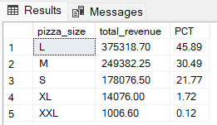

**F. Total Pizzas Sold by Pizza Category**

SELECT pizza_category, SUM(quantity) as Total_Quantity_Sold

FROM pizza_sales

WHERE MONTH(order_date) = 2

GROUP BY pizza_category

ORDER BY Total_Quantity_Sold DESC

**G. Top 5 Pizzas by Revenue**

SELECT Top 5 pizza_name, SUM(total_price) AS Total_Revenue

FROM pizza_sales

GROUP BY pizza_name

ORDER BY Total_Revenue DESC

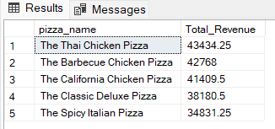

**H. Bottom 5 Pizzas by Revenue**

SELECT Top 5 pizza_name, SUM(total_price) AS Total_Revenue

FROM pizza_sales

GROUP BY pizza_name

ORDER BY Total_Revenue ASC

**I. Top 5 Pizzas by Quantity**

SELECT Top 5 pizza_name, SUM(quantity) AS Total_Pizza_Sold

FROM pizza_sales

GROUP BY pizza_name

ORDER BY Total_Pizza_Sold DESC

**J. Bottom 5 Pizzas by Quantity**

SELECT TOP 5 pizza_name, SUM(quantity) AS Total_Pizza_Sold

FROM pizza_sales

GROUP BY pizza_name

ORDER BY Total_Pizza_Sold ASC

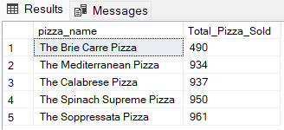

**K. Top 5 Pizzas by Total Orders**

SELECT Top 5 pizza_name, COUNT(DISTINCT order_id) AS Total_Orders

FROM pizza_sales

GROUP BY pizza_name

ORDER BY Total_Orders DESC

**L. Borrom 5 Pizzas by Total Orders**

SELECT Top 5 pizza_name, COUNT(DISTINCT order_id) AS Total_Orders

FROM pizza_sales

GROUP BY pizza_name

ORDER BY Total_Orders ASC

***NOTE***

If you want to apply the pizza_category or pizza_size filters to the above queries you can use WHERE clause. Follow some of below examples

SELECT Top 5 pizza_name, COUNT(DISTINCT order_id) AS Total_Orders

FROM pizza_sales

WHERE pizza_category = 'Classic'

GROUP BY pizza_name

ORDER BY Total_Orders ASC